Соболева Т.И.
Областное государственное бюджетное профессиональное образовательное учреждение «Рязанский строительный колледж имени Героя Советского Союза В.А. Беглова» (ОГБПОУРСК)
г. Рязань

Методическая разработка «Строительные машины»
Пояснительная записка
Данное методическое пособие предназначено для студентов дневной формы обучения специальности 08.02.01 «Строительство и эксплуатация зданий и сооружений» и 08.02.11 «Эксплуатация многоквартирного дома».
Основная цель учебного пособия – развитие и совершенствование навыков устной коммуникации и письменной речи в рамках предложенной тематики.
Структура пособия представлена следующими занятиями по темам:
- классификация строительных машин;
- землеройные машины;
- погрузо-разгрузочные механизмы;
- бетономешалки
Все разработанные занятия учебного пособия имеют единую структуру и включают следующие этапы: введение, базовая лексика каждого занятия, тексты по специальности, тренировочные упражнения. При составлении текстов и упражнений уделено большое внимание повторяемости лексических и грамматических явлений и использован принцип постепенного нарастания трудностей, что позволяет лучше усваивать материал. Задания сформулированы так, что обучающиеся могут работать самостоятельно, включая дистанционную форму обучения.
Данное методическое пособие будет способствовать достижению нового качества подготовки специалистов среднего звена на уровне современных квалификационных требований.
Занятие №1 Classification of Construction Equipment
1. Соотнесите английские слова с их русскими эквивалентами
1. construction equipment | a) изогнутый отвал
2. hand tool | b) насосные машины
3. earth-moving machinery | c) трактор
4. hoisting machinery | d) строительная бригада
5. pumping machines | e) подъемные машины
6 tractor | f) землеройные машины
7. steep slope | g строительное оборудование
8. excavate | h) ручной инструмент
9. curved blade | i) землечерпалка, экскаватор
10. construction crew | j) крутой склон
2. Прочтите и переведите текст письменно
Construction equipment is machinery used to build and demolish bridges, buildings, and other structures. These machines usually save labor, money, and time. One of them can do more work in an hour than a hundred workers using hand tools could do in a day. The chief kinds of
building machines include:
- earth-moving machinery
- hoisting and material-handling machinery
- pumping machines.
Earth-moving machinery is used to excavate, haul, and level earth and rock. These machines clear the way for the construction of bridges, buildings, and roads.
Hoisting and material-handling machinery is used to transfer construction materials from place to place.
Pumping machines are used to remove the water from construction site
3. Ответьте на вопросы
What is construction equipment?

What are the chief kinds of building machines?
What types of construction machines do you know?
- Выберите правильный вариант ответа.
- Construction machines can do more work in ____ than a hundred workers using hand tools could do in a day.
a) 2 hours b) an hour c) 3 hours
- These machines usually___ labor, money, and time
- save b) get c) take
5. Заполните пропуски соответствующими словами из текста
1. Construction equipment is machinery used to___
2. The chief kinds of building machines include___
3. Earth-moving machinery is used___
4. Hoisting and material-handling machinery is used to____

Занятие №2 Earth-moving Machinery (Землеройные машины)
- Выпишите и переведите выделенные слова

Construction workers widely use earth-moving machinery for different purposes. These machines are tractors, excavators, bulldozers, trenchers, backhoe, and dragline excavators.

2. Прочтите и переведите текст

1. Excavators
Excavators are important and widely used equipment in construction industry. Their general purpose is to excavation but other than that they are also used for many purposes like heavy lifting, demolition, river dredging, cutting of trees etc.
Excavator contains a long arm and a cabinet. At the end of long arm digging bucket is provided and cabinet is the place provided for machine operator. This whole cabin arrangement can be rotatable up to 360º which eases the operation. Excavators are available in both wheeled and tracked forms of vehicles.
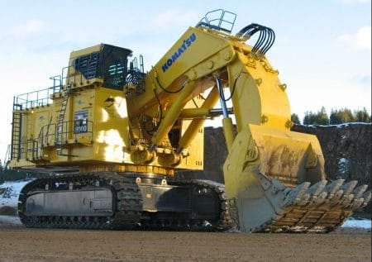

2. Backhoe
Backhoe is widely used equipment which is suitable for multiple purposes. The name itself telling that the arrangement is provided on the back side of vehicle while loading bucket is provided in the front.
This is well useful for excavating trenches below the machine level and using front bucket loading, unloading and lifting of materials can be done.
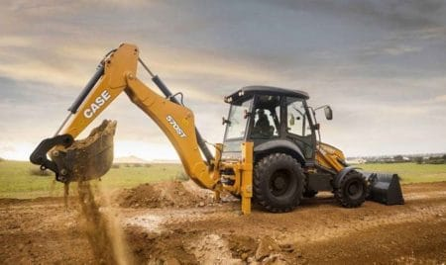

3. Dragline Excavator

Dragline excavator is heavy equipment used in construction which is generally used for larger depth excavations. It consists a long length boom and digging bucket is suspended from the top of the boom using cable.
For the construction of ports, for excavations under water, sediment removal in water bodies etc. can be done by dragline excavator.
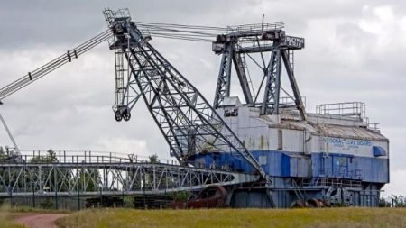

4. Bulldozers
Bulldozers are another type of soil excavating equipment which are used to remove the topsoil layer up to particular depth. The removal of soil is done by the sharp edged wide metal plate provided at its front. This plate can be lowered and raised using hydraulic pistons.
These are widely used for the removal of weak soil or rock strata, lifting of soil etc.
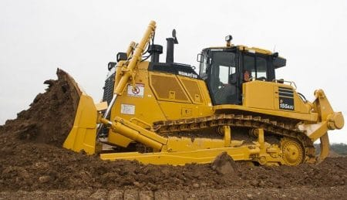

5. Graders
Graders also called as motor graders are another type of equipment used in construction especially for the construction of roads. It is mainly used to level the soil surface. It contains a horizontal blade in between front and rear wheels and this blade is lowered in to the ground while working. Operating cabin is provided on the top of rear axle arrangement.
Motor Graders are also used to remove snow or dirt from the roads, to flatten the surface of soil before laying asphalt layer, to remove unnecessary soil layer from the ground etc.
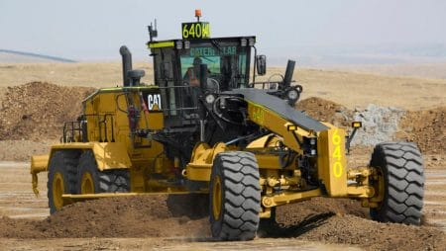

6. Trenchers
Trenchers or Trenching machines are used to excavate trenches in soil. These trenches are generally used for pipeline laying, cable laying, drainage purposes etc. Trenching machines are available in two types namely chain trenchers and wheeled trenchers.
Chain trenchers contain a fixed long arm around which digging chain is provided. A wheeled trencher contains a metal wheel with digging tooth around it. To excavate hard soil layers, wheeled trenchers are more suitable. Both types of trenchers are available in tracked as well as wheeled vehicle forms.
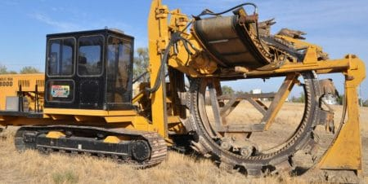
3. Ответьте на вопросы
- What purposes are excavators used for?
- Where do we backhoe use?
- What is dragline excavator?
- What do bulldozers do?
- What equipment is suitable for the construction of roads?
- What purposes are trenches used for?
4. Заполните пропуски соответствующими словами из текста
- Excavators are also used for many purposes like_____
- Backhoe is another widely used equipment which_____
- The construction of ports,____ can be done by dragline excavator.
- Bulldozers are another type of soil excavating equipment_____
- Motor Graders are also used to remove snow or____
- These trenches are generally used for_____
Занятие № 3 Construction Machinery (Строительная техника)
1. Прочитайте и переведите текст
Hoisting and material-handling machinery is used to transfer construction materials from place to place. Loaders are used in construction site to load the material onto dumpers, trucks etc. The materials may be excavated soil, demolition waste, raw materials, etc. A loader contain large sized bucket at its front with shorter moving arm.
Loader may be either tracked or wheeled. Wheeled loaders are widely used in sites while tracked or crawled loaders are used in sites where wheeled vehicles cannot reach.
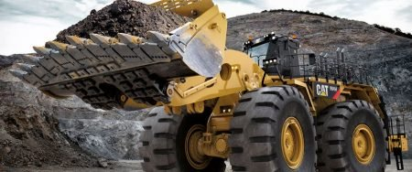
Construction crews working on tall structures use hoisting machines called cranes and derricks to lift steel beams and other parts. Companies working on tall buildings use material lifts to raise crews, masonry, and various construction materials. The lifts consist of steel towers with hoist-operated platforms that travel up and down the side of a building.
Tower cranes are fixed cranes which are used for hoisting purposes in construction of tall structures. Heavy materials like pre-stressed concrete blocks, steel trusses, frames etc. can be easily lifted to required height using this type of equipment.
They consists of mast which is the vertical supporting tower, Jib which is operating arm of crane, counter jib which is the other arm carries counter weight on rear side of crane and an operator cabin from which the crane can be operated.
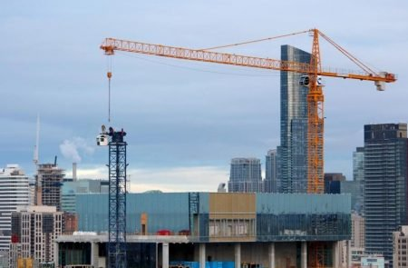
Dumpers or dump trucks haul heavy loads of earth gravel, and sand over unpaved roads.
Dump trucks are used in construction sites to carry the material in larger quantities from one site to another site or to the dump yard. Generally, in big construction site, off-road dump trucks are used. These off-road dump trucks contain large wheels with huge space for materials which enables them to carry huge quantity of material in any type of ground conditions.
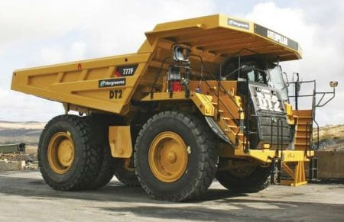
Other construction machinery prepares land and materials for construction. Self-propelled or tractor-drawn rollers press down ground to make it more compact and stable before paving. The various types of rollers include smooth, steel drums; multityred wheels; and drum rollers. Compactors or Rollers are used to compact the material or earth surface. Different types of compactors are available for different compacting purposes.
Smooth wheel rollers are used for compacting shallow layers of soil or asphalt etc. sheep-foot rollers are used for deep compaction purposes. Pneumatic tyred rollers are used for compacting fine grained soils, asphalt layers etc.
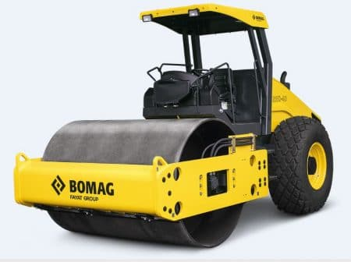

Pile Boring Equipment is used to make bore holes in the construction site to install precast piles. Devices called pile drivers drive piles (posts that support buildings and other structures) into the ground.
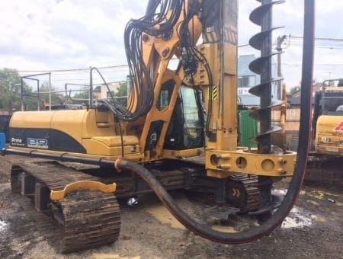
Heavy equipment used in construction site is pile driving equipment in case of pile foundation construction. This equipment lifts the pile and holds it in proper position and drives into the ground up to required depth.
Different types of pile driving equipment are available namely, piling rigs, piling hammer, hammer guides etc. in any case the pile is driven into the ground by hammering the pile top which is done hydraulically or by dropping.
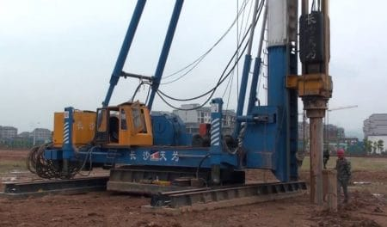
Pumping machines are used in construction work to move water and other substances from one place to another. Pumps move clean water to mix with cement and remove dirty water from excavation pits.
Demolition machinery is used to demolish structures and pavement.
2. Ответьте на вопросы:
  - What is hoisting and material-handling machinery used to?
  - What do dumpers or dump trucks haul?
  - Where are pumping machines used?
  - What other construction machinery prepares land and materials for construction?
Занятие №4 Concrete mixer (Бетономешалка)
1.Заполните таблицу строительных машин из предложенных слов:
Excavator, backhoe, dragline excavator, bulldozer, grader, wheel tractor scraper, trencher, loader, tower crane, paver, compactor, telehandler, concrete mixer, derrick, dumper, pumping machines, roller, crusher, asphalt mixer, truck, pile driver
Earth – moving Machinery
Hoisting and material-handling Machinery
Road Machinery
Others
2. Прочитайте и переведите текст

Other material-handling machines include mobile cement mixers and conveyor belts. Companies use mobile cement mixers to mix concrete while hauling it to work sites. Materials move on conveyor belts inside buildings or over rough ground.

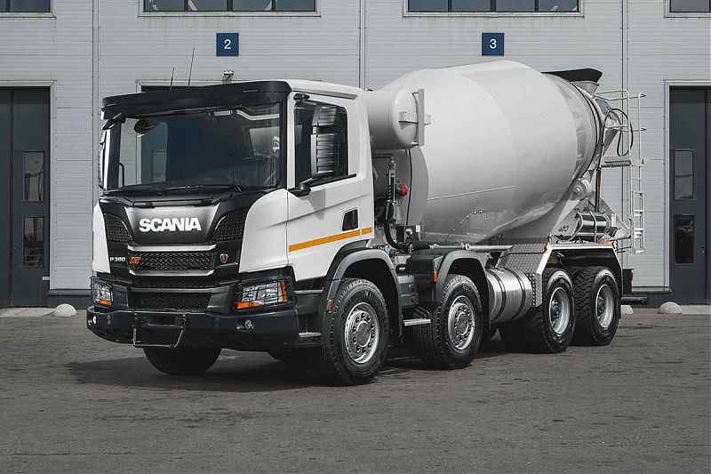
A concrete mixer (also commonly called a cement mixer) is a device that homogeneously combines cement, aggregate such as sand or gravel, and water to form concrete. A typical concrete mixer uses a revolving drum to mix the components. For smaller volume works portable concrete mixers are often used so that the concrete can be made at the construction site, giving the workers ample time to use the concrete before it hardens. Special concrete transport trucks are made to transport and mix concrete from a factory to the construction yard. They are charged with dry materials and water, with the mixing occurring during transport. The interior of the drum on a concrete truck is fitted with a spiral blade. In one rotational direction, the concrete is pushed deeper into the drum. This is the direction the drum is rotated while the concrete is being transported to the building site. This is known as "charging" the mixer. When the drum rotates in the other direction, it forces the concrete out of the drum. From there it may go onto chutes to guide the viscous concrete directly to the job site. If the truck cannot get close enough to the site to use the chutes, the concrete may be discharged into a concrete pump connected to a flexible hose, or onto a conveyor belt which can be extended some distance (typically ten meters). A pump provides the means to move the material to precise locations, multi-floor buildings, and other distance prohibitive locations.
3. Ответьте на вопросы
- What do material-handling machines include?
- What is a concrete mixer?
4. Найдите в тексте эквиваленты следующих слов
Устройство, достаточный, однородность, загрузка, барабан, вязкий (густой, тягучий), вращаться, желоб, насос

Информационное обеспечение обучения
  - Конышева, А. В. Ehglish for builders = Английский для строителей: пособие для студентов строительных специальностей высших учебных заведений / А. В. Конышева. – Минск: БНТУ, 2022. – 89 с.
  - https://sgmtrucks.ru/articles/spetstekhnika-chto-k-ney-otnositsya/(дата обращения 31.03.2026)
  - https://www.litres.ru/book/a-i-monvizh-montvid/stroitelnaya-tehnika-69756523/ (дата обращения 31.03.2026)

